De : Joëlle Ferly
L’Artocarpe
Contemporary Art contemporain Date : 07 . 01. 2014
Le Moule - Guadeloupe

www.artocarpe.net

Attention : To all international* professional artist, in contemporary art

Objet : Open call for a residence at L’Artocarpe – April – August 2014

Dear Artist,

L’Artocarpe is pleased to offer a new residence to one artist* within our space in Guadeloupe, French Caribbean. To apply, please complete the enclosed form and send it via email along with your application.
Please note that L’Artocarpe being an artist-run organisation, the prospective artist is required to understand that he/she will have to be fully independent and accept the terms and conditions to come and stay with L’Artocarpe.

You will be pleased to know that your application will be assessed by top range French curator, Regine Cuzin, who is joining the Board of Directors of L’Artocarpe.

Deadline: Monday 20th January 2014.
Application are to be sent via mail only: artocarpe@gmail.com

We look forward to receiving your application!

Regards,

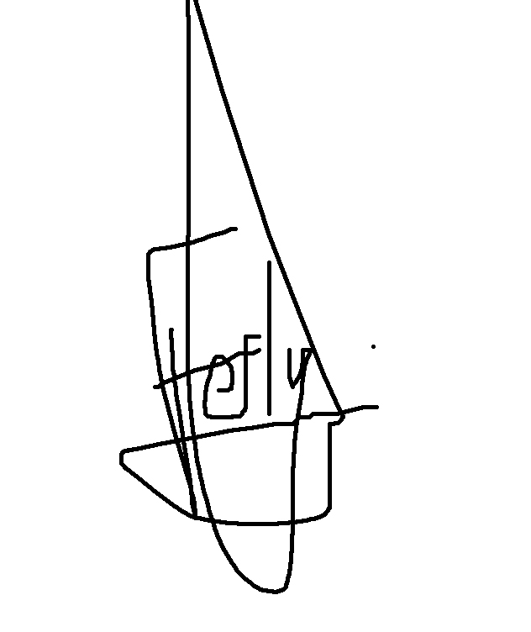
*This call is not open to French citizens

Joëlle Ferly
Présidente de L’Artocarpe
Le saviez-vous? L’Artocarpe est le nom scientifique de l’arbre à pain!
Did you know? L’Artocarpe is the scientific name of the Breadfruit tree!

APPLICATION FORM – AIR 2014
please be specific as this will be the guidelines for us to decide if we can offer you the residence.

Name :……………………………………………………
Surname : ……………………………………………………
Artist name : ……………………………………………………
Postal Address : ……………………………………………………
……………………………………………………
……………………………………………………
……………………………………………………
Country of birth:…………………………………………………..
Date of birth :…………………………………………………..
Mother tongue :……………………………………………………
Languages :……………………………………………………
Email address : ……………………………………………………
Landline Phone : ……………………………………………………
Mobile phone : ……………………………………………………
Skype account : ……………………………………………………
Website (s) : ……………………………………………………
……………………………………………………
……………………………………………………
Facebook : ……………………………………………………

Your residency with us

Period preferred: ……………………………………………………
Number of days : ……………………………………………………
Give an indication of what you intend to do during your residence in a few lines:
…………………………………………………………………………………………………………
…………………………………………………………………………………………………………
…………………………………………………………………………………………………………
…………………………………………………………………………………………………………
…………………………………………………………………………………………………………

The residency is to offer the following:
- Your transportation from and to your home (note that we cannot pay for your artwork transportation when you leave the residence)
- Your insurance
- Your stamp for entry into Guadeloupe (when appropriate)
- One meal a day
- Per diem to cover daily expenses (local transport, other meals , phone calls from local mobile etc.)
- A personal double-bed room
- A personal studio
- Unlimited access to wi-fi (you need to have your own computer)
- Access to L’Artocarpe’s library
- Administration fees to be part of L’Artocarpe network
- A lump sum to cover material /equipment that you may need

Your financial needs
In order to assess the expenses to be covered by L’Artocarpe: give us an indication of the fees in EUROS (€) of your need:
Air Ticket : ………………………………………………………….
Flying from /to : …………………………………………………………..

Per diem : ( ??? € x number of ???days = total :……………€

Material fees : ………………………………………………………….
Material list : ………………………………………………………….
……………………………………………………………
……………………………………………………………
……………………………………………………………
……………………………………………………………
……………………………………………………………
……………………………………………………………
……………………………………………………………
……………………………………………………………

Total budget required approximately:……………………………….€

Your input
L’Artocarpe is happy to offer a residence to foreign artists. Note however that such initiative is fully funded by our partners. Our partners ask in return that invited artist commit to certain activities in order to engage with members of L’Artocarpe, other local artists and professionals as well as art with the general public and representative of public bodies.

Please indicate what you are prepared to get involved in:
❑ Open studio days. To let the public come to see you working, answering questions and taking them to the understanding of your art practice.
❑ Conference. To present your work to a public, using visuals to do so.
❑ Workshops. To set up a workshop for other members of L’Artocarpe
❑ School presentation. To visit school and present your work, in some cases run a workshop (some of these could generate income to you, depending of the school. Note that the only art school is based in Martinique: previous residents were invited to give a paid workshop there.)
❑ Training. To enable a targetting audience to learn professional skills (some of these could generate extra income to you)
❑ Portfolio review. To view the porfolio of artist members of L’Artocarpe and exchange with them
❑ Meeting. Present yourself to the representative of our partners, who are financing your residence
❑ Exhibition. To present the finishing work created during the residence. Not compulsory!
❑ Lectures. To present a conference on the theme of your choice, that you master
❑ Other: …………………………………………………………………………………………..
Although we appreciate that your main concern while being in residence is to work on your art, we also require that you commit to the basic house chores in order to keep the space clean. All accepted artist, whether male or female will have to play the game in this respect, not just to accept and sign the Policies Agreement and their Art Residency Contract prior to come to the residence, take the money and then behave badly!
In advance thank you for your cooperation

Your portfolio

To complete the present application, please send us your portfolio. Note that there is no rule as to what should be such documentation. We shall consider the feasibility of your application on both your personal creative work as well as the realistic administratic aspects for us to meet your needs.
We understand that some artists may only like to present work already completed (exhibition catalogues, pictures of artwork display in galleries…), others may prefer to focus on the presentation of the project that they intend to develop while in residence.
It is entirely up to you!

However, keep in mind that:
- Your application will be fully assessed digitally: do not send print size format files! Add link to websites if you want.
- When sending several mail, mark them as: AIR Application 1/3; AIR Application 2/3; AIR Application 3/3;
- The more information you give, the better: but do not put too long!
- The board as well as some members of L’Artocarpe (artists like yourself!) will take into account all aspects of your application: do not neglect any!
- No need to lie!: if you are stressed “delivering a conference” then do not tick the box! As you may find yourself having to speak in front of a huge theatre full of people including top Heads of cultural offices…

All information given in this application will remain strictly confidential. However, on the announcement of your nomination, should the case be, we shall ask for further material (your picture etc) to be put on our website.

We look forward to receiving your application!
Deadline: Monday 20th January 2014

